Revision Exercise: Section B - ANSWERS
The exam won’t necessarily contain these questions exactly, but you can hopefully use them to get an idea of the types of things you’ll be asked. You can also see an approximate idea of how marks are generally allocated.

Exercise 1
Twelve participants were asked to solve a series of particularly difficult mathematical problems whose answers are all based on the same set of rules that are very difficult to explain. During the training session, participants were asked to solve 80 problems. In the test session, they had to solve a second set of 80 problems. For each session, the percentage of correct answers to the question asked was measured. The data are presented in the table below:

Table 1.
Percentage of correct answers

Participant | Training | Test
1 | 31 | 37
2 | 16 | 24
3 | 26 | 31
4 | 24 | 29
5 | 23 | 29
6 | 22 | 25
7 | 22 | 26
8 | 20 | 22
9 | 14 | 20
10 | 25 | 29
11 | 9 | 15
12 | 13 | 17

Data Familiarisation

Descriptives
 |  | N |  | Mean |  | SD |  | SE
Training |  | 12 |  | 20.42 |  | 6.29 |  | 1.81
Test |  | 12 |  | 25.33 |  | 6.23 |  | 1.79

Shapiro-Wilk
 |  |  |  |  |  | W |  | p
Test |  | - |  | Training |  | 0.95 |  | .705

Test Results
Measure 1 |  |  |  | Measure 2 |  | Test result |  | df |  | p |  |  | Effect size
Test |  | - |  | Training |  | 10.50 |  | 11 |  | < .001 |  | 3.03

- What is the IV? And the DV?
(3 marks: 1 = correct IV, 1 = correct DV, 1 = correct measurement/units)
The IV is the Type of session (training and test)
The DV is the percentage of correct answers (ratio scale).

- What is the design of the study?
(2 marks: correct design)
Each participants took part in all the sessions, therefore it is a within subjects/repeated measures.

- What inferential test the researcher should use?
(2 marks: correct t-test)
The researcher is interested in the difference between the scores, the design is within subject, therefore, if the assumptions of parametric test are met, the researcher should perform a paired samples t-test

- What is the alternative hypothesis?
(3 marks: 2 = correct alternative, 1 = correct direction of alternative)
For the alternative hypothesis, given that the researcher doesn’t specify a direction we can predict that there will be a difference in the percentage of correct responses between training and test.

- The results of the test are presented below, summarize the findings and give a conclusion.
(8 marks: as follows:
1 = correct IV/DVS
1 = repeated the research question / aim
1 = assumptions, Shapiro-Wilk reported
1 = correct test reported
1 = correct ‘line of results’
1 = state significance
1 = descriptives discussed
1 = interpret result)

All the assumptions of a parametric test were met: the DV is measured on a ratio scale, data are approximately normally distributed (W = .95, p = .705) and there were no outliers identified. A paired-samples t-test was used to determine whether there was a statistically significant mean difference between the percentage of correct answers between the training and the test phase. Results showed that that participants scored on average significantly higher in the test condition (M = 25.33, SD = 6.23) than the training condition (M = 20.42, SD = 6.29), (t(11) = 10.50, p <.001, d = 3.03). These results suggest that performances improved from training compared to test phase.

- The researcher decided to run a two-tail test, explain why it is appropriate.
(2 marks: correct justification)
As there was no directional hypothesis given, a two-tailed test is the most appropriate.

Exercise 2

It is a very well-known phenomenon that if someone looks at an object, people will automatically look at the same object – this is referred to as ‘gaze cueing’. A group of researchers decided to look at this phenomenon using a classical Posner Cueing Task paradigm. They presented a central face to participants. The face looked to the same side (congruent), to the opposite side (incongruent) as a target or to a neutral (middle) position. They recorded whether participants saw the target (yes/no answer). The results are presented below. Assumptions of the test were met.
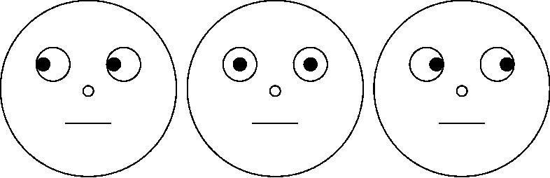

Table 2.
Frequency table of the participants’ answers and the type of cues
 |  | Type of cue
 |  | Neutral | Incongruent | Congruent
Participant’s answer | Yes | 41 | 16 | 63
 | No | 22 | 27 | 51

Results
 |  |  |  | Cue
Answer |  |  |  | Neutral |  | Incongruent |  | Congruent |  |  | Total
Yes |  | Count |  | 41 |  | 16 |  | 63 |  |  | 120
 |  | Expected count |  | 34.36 |  | 23.45 |  | 62.18 |  |  | 120
No |  | Count |  | 22 |  | 27 |  | 51 |  |  | 100
 |  | Expected count |  | 28.64 |  | 19.54 |  | 51.82 |  |  | 100
Total |  | Count |  | 63 |  | 43 |  | 114 |  |  | 220
 |  | Expected count |  | 63 |  | 43 |  | 114 |  |  | 220

 |  | Value |  | df |  | p
Test Result |  | 8.06 |  | 2 |  | .018
N |  | 220

- What type of data is this?
(2 marks: correct data)
Data are Nominal

- What kind of analysis would one use to analyse this data?
(3 marks: 1 = correct test, 1 = variables identified, 1 = categorical variables)
Here the researcher should use a Chi-square test of association (or 3x2 Chi Square test of association). The first variable is the type of cue, with three categories: congruent, incongruent or neutral. The second variable is whether the target is detected or not, with two categories.

- The results of the test are presented below. How would the results be written up?
(8 marks: as follows:
1 = correct variables (units)
1 = repeated the research question / aim
1 = assumptions met
1 = correct test reported
1 = correct ‘line of results’
1 = state significance
1 = descriptives discussed
1 = interpret result)

Researchers measured how many participants noticed a target face (yes/no answer) that was next to a central face to participants where the face either looked to the same side (congruent), or to the opposite side (incongruent). All assumptions were met. The results of the Chi² Test of Association showed that there is a significant association between whether the target is detected or not (participant’s answer) and the type of cue (χ² (2, 220) = 8.06, p = .018). For both participants who had / had not reported seeing the cue, there was a tendency to prefer the “Congruent” face, with 63 preferring the "Congruent" cue in the “Yes” response, and 51 preferring the “Congruent” cue in the "No" response, with observed counts deviating slightly from the expected values.

- What would the researcher conclude from this output?
(3 marks: correct / additional descriptive interpretation)
For the neutral cue, there were more yes answers but less no answers than what was expected, whilst for the incongruent cues it is the reverse. There were less yes answers but more no answers than expected. For the congruent cues, the observed and expected counts is approximately the same. For both participants who had / had not reported seeing the cue, there was a tendency to prefer the “Congruent” faces.

- Imagine that you were asked to redesign this study to have an experimental design. Which variable would you choose to change, and how would you change it?
(4 marks: 1 = appropriate variable, 1 = number of conditions / levels discussed, 2 = how would you change the design)
You could redesign the study in a number of ways, but the easiest would probably be to make the eye gaze variable into the independent variable with three independent conditions: towards target, straight ahead, and away from target. The detection variable could then be changed into a continuous variable to become a dependent variable. For example, it could be time take to detect the stimuli (in milliseconds).

Exercise 3

The owner of a supermarket wants to investigate the average waiting time at checkouts and see if there is a relationship between the number of checkouts opened and waiting time. For 7 days, he recorded the number of checkouts opened and the average waiting time (in minutes). The supermarket owner predicts that where the number of checkouts opened increases, the average waiting time will decrease. The results of the analysis are reported below. Regarding the assumption checks: a Shapiro-Wilk test revealed

Table 3.
Average waiting time (in minutes) and number of checkouts open
Weekday | Number of checkouts open | Average waiting time (in minutes)
Monday | 3 | 16
Tuesday | 4 | 12
Wednesday | 5 | 9.6
Thursday | 6 | 7.9
Friday | 8 | 6
Saturday | 10 | 4.7
Sunday | 12 | 4

Shapiro-Wilk
 | W | p
Checkouts open | 0.951 | 0.705
Wait time | 0.499 | 0.420

Figure 1.

Number of checkouts open vs. Average waiting time (in minutes)
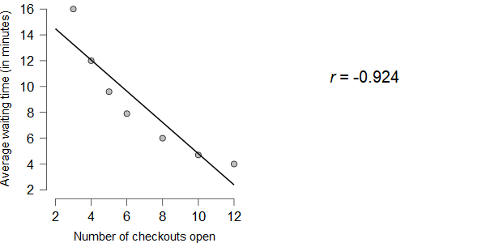

Results
 |  |  |  |  |  | Test |  | p
Number of checkouts open |  | - |  | Average waiting time (mins) |  | -0.924 |  | 0.041

- What test did the supermarket owner decided to conduct?
(2 marks: 1 = correct test, 1 = correct explanation)
The supermarket owner wants to investigate the relationship between the number of checkouts and the average waiting time. Therefore, they performed a correlation.

- Why is it the most appropriate?
(2 marks: correct justification)
The owner did not manipulate variables, they just measure two continuous variables at the same time. Looking at Figure 1 we can see that there is a linear relationship and no outliers. Thus, the supermarket owner should perform a Pearson correlation.

- What was the supermarket owner’s hypothesis?
(2 marks: 1 = correct hypothesis, 1 = correct direction)
There hypothesis is that there will be a negative relationship between the number of checkouts opened that the average waiting time.

- Write up and interpret the results.
(8 marks: as follows:
1 = correct variables (units)
1 = repeated the research question / aim
2 = assumptions met (Linearity and Shapiro-Wilk)
1 = correct test reported
1 = correct ‘line of results’
1 = state significance
1 = interpret result)

A supermarket owner wanted to investigate the average waiting time at checkouts to see if there was a relationship between the number of checkouts open and waiting time (in minutes). As seen in Figure 1, the relationship was linear, and both variables: checkouts open (W = .95, p = .705) and Wait time (W = .50, p = .420) were normally distributed. A Pearson’s correlation test revealed a significant negative correlation between number of checkouts open and average waiting time (r(5) = -.92, p = .041).
This means, that as the number of checkouts opened increases, the average waiting time significantly decreased.

- Does the analysis support the supermarket owner’s prediction?
(2 marks: 1 = yes answer, 1 = justification)
Yes, the prediction is supported because the owner also predicted a negative relationship and the data support this.

- The supermarket owner thinks that whether the shop is busy or not might have an effect on the awaiting time. To examine this, he wants to analyse the possible correlation between waiting times and if the shop is busy or not busy. Are there any possible problems with the suggested analyses? If yes, explain the problem.
(4 marks: 1 = yes answer, 3 = reasons / justification)
The problem with the proposed analyses is the whether the shop is busy or not is a nominal variable, with two categories, and therefore it is not suitable for analysis using a correlation.

